|  |  |
| --- | --- |
| [Unit Code] Assignment 1 Report | Version: 1.0 |
| Team Name: PANDATECH | Date: [2020-04-20] |
| Title: Assignment 1 | |

# Introduction

The website was established since 2015 by 3 young men, three of them united to create this website and hoping to help people in Malaysia to find their ideal gaming accessories. The objectives of the website are to create an informative, modern and attractive website to promote gaming keyboard, gaming mouse and gaming controller. Other than that, the website also aims to provide the best quality and the latest gaming accessories.

**1.1 Scope of the website**

PANDATECH was created to sell gaming keyboards, gaming mouse and gaming controllers. The website allows visitors to browse through different sorts of product. In addition to that, the website also provides an enquiry form for the visitors in case they encounter a problem or have any question regardless of the product. Furthermore, the website contains a feedback form that allows the visitors to submit feedback on the website with ease.

**1.2 Intended audience**

The target audience is people of all ages, genders and background, as long as they have a passion for gaming. Other than that, people that wish to buy a decent keyboard, mouse or controller is also part of our target audience. There is no requirement for someone to be a gamer as long as they are passionate about it. However, the target audience must have a sufficient amount of money to purchase their ideal keyboards, mouse and controller.

**2.0 Webpage Design and Structure**

**2.1 Website Layout Mock ups**

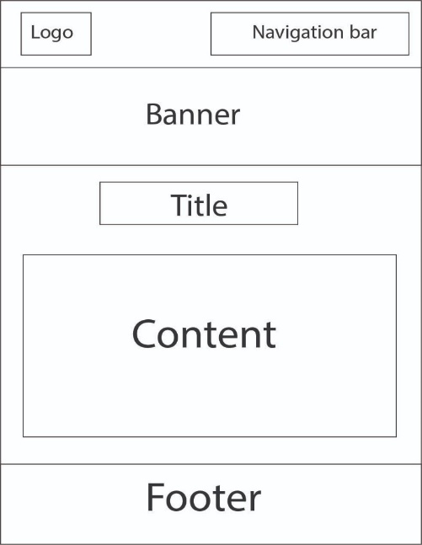

The image above represents the collective layout for the website’s primary webpages: Homepage (index.html), Gaming mouse (product2.html), Gaming keyboard (product1.html) and Gaming controller (product3.html)

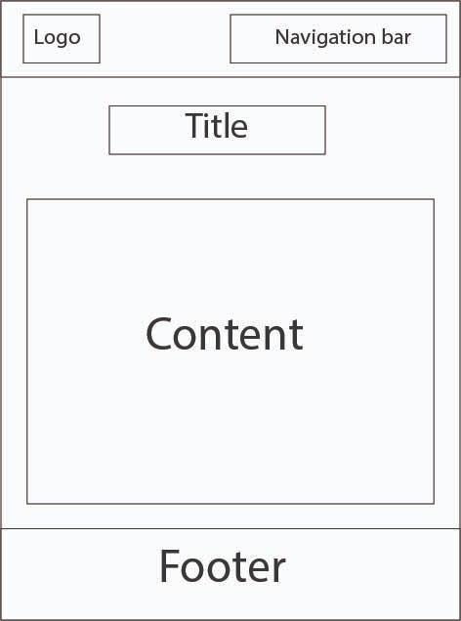

The image above represents the collective layout for the website’s secondary webpages: Enquiry (enquiry.html), Disclaimer (disclaimer.html), About me 1(aboutme1.html), About me 2 (aboutme2.html), About me 3(aboutme3.html), Feedback(feedback.html) and Order(order.html).

**2.2 Website structure**

Homepage

Enquiry

Gaming Controller

Gaming Mouse

Gaming Keyboard

Profile 2

Profile 1

Order

Feedback

Product 4

Disclaimer

Enhancement

Profile 3

**3.0 End Product**

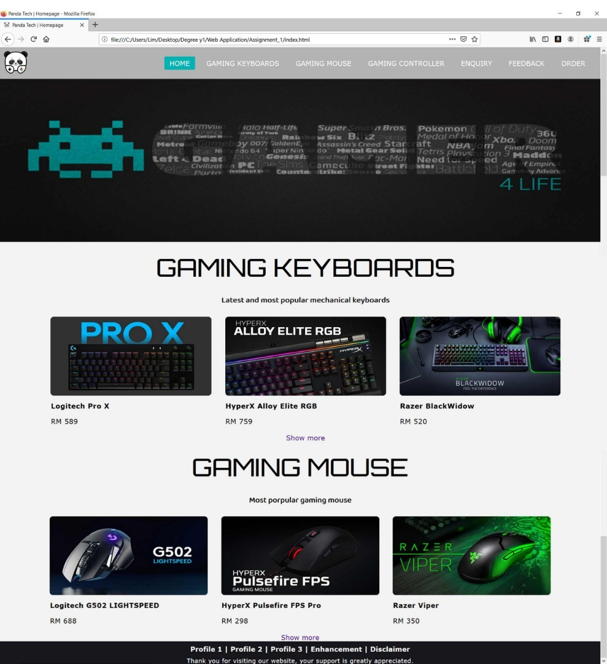 **3.1 Actual User Interface**

The homepage is well balance with asymmetrical design. The images in the gaming keyboard section and the gaming mouse section are symmetrical balance in the border, while the banner is symmetrical balance with both section, and all of these elements created a website with an asymmetrical balance. An asymmetrical website can catch the attention of the user when they enter the website. There are white spaces between all the image and text so that the content on the website is more readable, avoid clutter and looks more organized. It achieved one of the web design principles which is proximity. The focal point of the website is the banner so that it can attract the user’s attention. The logo of the company is located at the top left corner of every web page. Therefore, the website also achieved the principle, contrast and focus. Other than that, all web pages have consistent and repetition of design elements. This will help to achieve unity on all web pages and maintain the web pages’ visual identity. The elements on the web page are aligned to each other so that the website will look more professional and consistent. All the content on the web pages can read easily so that the user will not have a 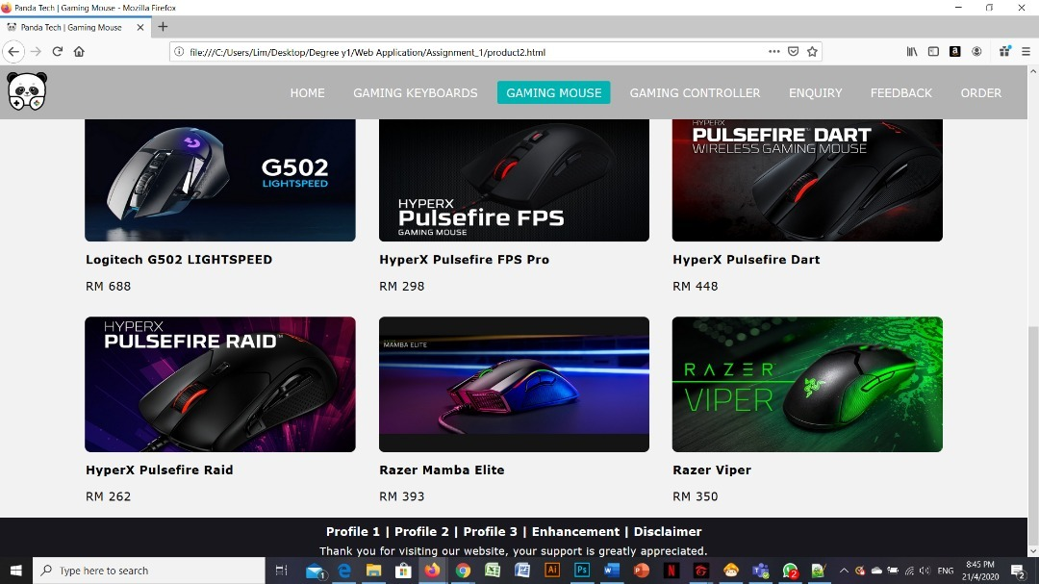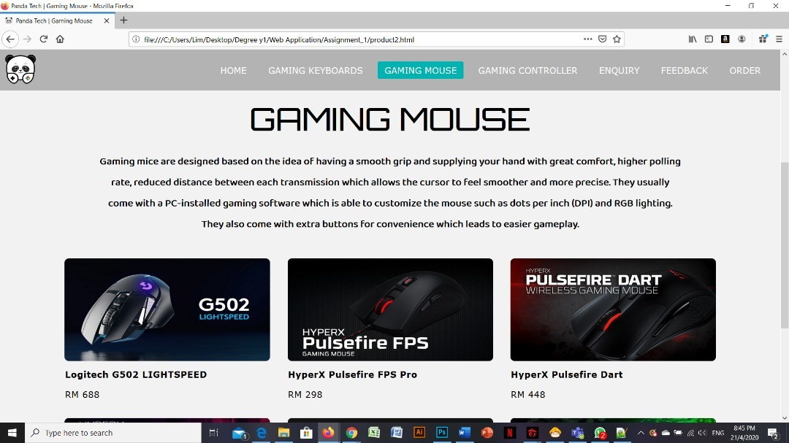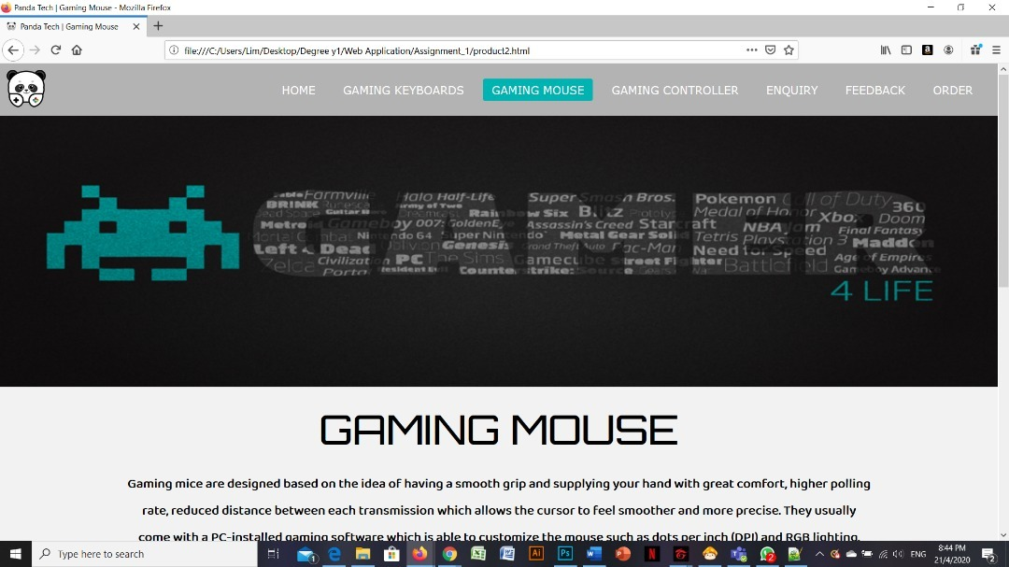hard time reading or scanning the content of the website.

The design of the product page is relatively simple, but it has all the basic web design principle. The images are symmetrically balanced with each other. White spaces between all the images define proximity. The link for a detailed description of the product will be displayed when the user hovers on the image. The general description for the product is displayed above all the product so that the user is sure of what they are looking for. The banner remains the focal point of the web page creating contrast and focus. The design element of the website is consistent with the home page so that all the web pages have unity and maintain the website’s visual identity.

**Web Design Elements**

**Typography and Graphics**

In the website, the font for the body text is “Verdana”. If the user’s internet browser does not support the font, there is two alternate font which is “Geneva” and “Sans-serif”. The font size for the body text is set to 17px so that the word can be seen clearly by the user. The letter-spacing is 0.5 pixels and the line height is 1.5em so that the text on the website will not look overcrowded and the content of the website will be clearer. The headings of the font are mainly “Orbitron” with the font size of 60 pixels. The font of the heading is designed to be more futuristic as the website sells products that are relevant to technology. The font for the secondary heading is “Bahaina2” with the font size of 20 pixels which is smaller than the primary heading but slightly larger than the body text. The font size is smaller, and the font is different when compared to the primary headings because this will help the user to distinguish the difference between the two headings and body text. The font of the body text and the heading are consistent with other web pages so that it will develop a strong visual identity. Other than that, all the products on the website are displayed with an image. When the user hovers on the image, the details of the product will show on the image. There is also a banner on every web page of the website. The text in the banner “Gamer 4 life” indicates that if the user bought any products from our website, the company will recognize the user as a gamer although they may not be a professional gamer.

**Colours**

The chosen background colour for the website is light grey (#f2f2f2), while the colour of the font is black in colour. Therefore, the information stands out from the website because the font colour is darker compare to the background colour. All of the text is black in colour to give a contrast of the main content with the light grey background behind. In the navigation bar, the colour of the links are white but it will turn into iris blue (#00b3b3). This will further allow the website to interact with the user. The “Submit”, “Submit Feedback” button and “Cancel” button will change into a darker colour when hover over. The “Submit”, “Submit feedback” button will change from grey(#70708f) into a darker colour which is Payne’s Grey (#383847), while the “Cancel” button will change from red (#FF0000) into a darker colour which is electric red(#e60000).

**Page Layout and Navigation**

The website comprises of a banner, main content, and a navigation bar. The website uses fluid layout thus most of the elements are set using percentage. Therefore, if the dimensions of the window change, the layout will change accordingly. The website also uses CSS based layout so that the website is easier to maintain. Every website has one navigation bar on the top of the banner. The navigation bar consists of “Home”, “Gaming Keyboard”, “Gaming Mouse”, “Gaming Controller”, “Enquiry”, and “Feedback”. Each of it will link to their corresponding webpage so that the website is easy to understand and user-friendly. When the website is minimized, the navigation bar will turn into a navigation icon and when the user clicks on the icon, the navigation will pop out vertically on the website so the content of the navigation bar won’t be packed at the corner when the website is minimized.

**3.2 Enhancement**

1. Responsive menu bar

The enhancement that we used on this website is a responsive menu bar, compared to the method we learned from the tutorial class which is a basic navigation link, the responsive menu bar looks much more attractive so that it could attract the user attention. Other than that, the responsive menu bar looks more concise than the basic navigation links especially when the user resizes the website. All our webpages on the website used a responsive menu bar.

2. Favicon

The small icon on the tab of the website which is a favicon. Even though, it is a small icon that some people might not even notice it but it is also important for letting the user make sure and confirm it is our company websites. From a view of branding point, it is very important as it shows a great deal of professionalism and attention to detail to the user.

3. Hover effect on image

The other enhancement that we used in our website is the hover effect on the image, so when the user is interested in that product, they will find out the effect and there is also a link provided to navigate the user to the specific product description website that will provide more details of the product which the user is interested in. Compared to what we have learned from our tutorial class which is inserted image on the website, this hover effect looks much more attractive and provide the user a new experience compared to some of the normal website. (Logitech G502 Lightspeed inside this pic have a link to navigate the user to its product description)

4. Embedded video

The last enhancement for our website is embedded youtube video. We embedded youtube video at our product description, as embedded video in a website can describe the product more clearly for the user and let them be more interested in the product we sell. (At product4.html have a video.)

**4.0 Contribution**

|  |  |
| --- | --- |
| **Team Member 1** | **Lim Yuan Shen** |
| **Contribution (%)** | **34** |
| **List of Contribution** | **Index.html, product1.html, order.html, aboutme2.html, enhancement.html** |
| **Team Member 2** | **Nathan Yong Hao Woei** |
| **Contribution (%)** | **33** |
| **List of Contribution** | **Enquiry.html, product2.html, feedback.html, aboutme3.html** |
| **Team Member 3** | **Daniel Cornelius Wong Yui Herng** |
| **Contribution (%)** | **33** |
| **List of Contribution** | **Disclaimer.html, product2.html, product4.hml, aboutme1.html** |

**5.0 Group Reflection**

The greatest challenge our group faced was definitely due to COVID-19, three of us have a hard time to work together because we can’t meet up and discuss the assignment and all of the discussion was done through video call so that we can elaborate our ideas. Other than that, we voice call each other when we are doing our website to make sure that all of us are on track and the id or class of our HTML code won’t clash so that we can avoid redundant code in CSS. During our discussion, all three of us have a different opinion on the website such as the design of the website and the product we plan to sell on our website. Time management is also one of the challenges we met, three of us have to set a time to create the website because we also have other errands to run such as assessment and quiz from other courses. Throughout the assignment, our group has learned how to manage time properly so that we won’t waste our time and how to do work more efficiently as a group. Although we completed our website, there are still areas of improvement such as we should brainstorm more so that the design of our website will become better and we should be confident in ourselves and voice out our own opinion.